Table of Contents
☐ WELCOME 2
☐ 1. Overview 3
☐ 2. Software Installation. 4
☐ 3. Main Tab 6
☐ 5. Rx/Tx Tab 7
☐ 6. Favs Tab 8
☐ 7. CW Tab 9
☐ 8. Calibration Tab 10
Frequency Calibration 10
I/Q Transmit Calibration 13
I/Q Receive Calibration 15
☐ 9. Power Cal Tab 17
☐ 10. Audio Tab 18
☐ 11. Comm Tab 23
☐ 12. Misc Tab 25
☐ 13. Operating CW 27
☐ Appendix A: Output Power Calibration 28
☐ Appendix B: New transceiver installation. 31
☐ Appendix C: Firmware Updates. 33
☐ Appendix D: Upgrading firmware from versions prior to 117.111 36
☐ Appendix E: Operating Notes 40
☐ Appendix F: Fortis Cube Notes 41

☐ WELCOME
This manual is the guide to installing and using MSCC (Multus SDR Control Console). MSCC is a Multus SDR, LLC, developed host application for use with the Multus SDR, Solidus and Fortis Cube. It has all the functions and features commonly found with other host applications. MSCC is designed to be easy to install, configure and use. MSCC has very low utilization foot print in both CPU and memory consumption. The main display is designed to provide all the operator controls normal used to control the transceiver. Once MSCC is configured the main display is normally all that is need to operator the transceiver. S-meter and panadapter displays are optional. MSCC has exceptional sound reproduction quality. MSCC is specifically tailored to provide optimal Multus SDR, LLC. Transceiver performance. It is not a one size fits all host application as is found with other SDR host applications.
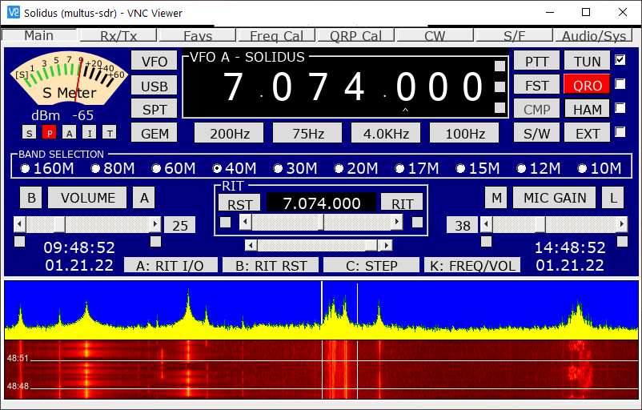

☐ 1. Overview
MSCC (Multus SDR Control Console) is the main interface with the transceiver. It implements all the features and functions commonly found with other SDR host applications and specifically developed for the Multus SDR, LLC transceivers. Please review the following slides and information regarding installation, configuration and using MSCC. MSCC works exclusively with Multus SDR, LLC transceivers. It will not function with other manufactures’ equipment.

☐ 2. Software Installation.
If not performed previously, download and install the MSCC installer package located here: MSCC Release Package (mscc-install.exe). It will install all the files needed for the transceiver. It will also install desktop shortcut icons for MSCC, and USBBootloaderHost along with a shortcut pointing to the release package. Instructions for using these applications are contained in this manual.
Advisories:
- Transceivers purchased after the revision date of this document do not need the firmware updated.
- For new installations on a PC that has never had the transceiver attached, refer to Appendix B for information regarding the installation of a required device driver before continuing with this operators guide.
- For existing transceiver installations consult the change log located in the release package folder to determine if a firmware update is required. The firmware is found in the previously installed release package directory. Instructions for installing the firmware may be found in Appendix B and Appendix C.
- Always consult the change log included in the release-package folder. It contains important release information.
- For new transceiver installations, MSCC must be installed and run so that the transceiver is configured with the correct default parameter values.
- Attach the transceiver and power cycle.

- 1) Click on the MSCC desktop icon. If this is the first time MSCC has run, a console window will be displayed. Enter a number based on the version of the transceiver PCB. Original transceiver PCBs have no version marking. Enter “1” for this version. Enter “2” for transceiver transceivers with a PCB marked with version “C”. Enter 4 for PCBs marked with a revision number of “Ver 4.3”. There is no revision 3 PCB.
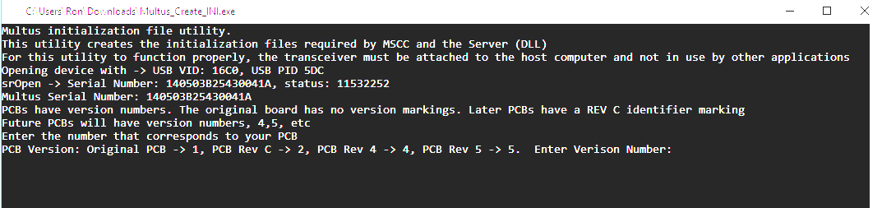
- Press the return key to exit this console window.
- Install the optional font. MSCC has been designed to use an optional LED type font. However it will be fully functional with out it. To install the optional font, click on the “advanced_pixel_lcd-7.ttf” file in the release-package directory. Windows will install the font.

☐ 3. Main Tab
After completing step #2 above MSCC will display the main tab. Most of the controls are intuitive and require little explanation. The startup frequency and band will be the last frequency and band that was set in the transceiver. If the transceiver was power cycled before starting MSCC the start up band will be 20M. If the last frequency set in the transceiver was in a broadcast band, MSCC will start with a frequency of 10MHz. Broadcast frequency setting are not maintain across subsequent restarts of MSCC. Now, go to section #8 in this manual to configure a microphone and speaker and return to this section
NOTES:
- Two methods are available for changing frequencies. When using a standard desktop mouse, moving the mouse onto a frequency digit will highlight the digit. Use the scroll wheel to increase or decrease the digit value. When using a laptop mouse pad, moving the mouse pointer to a point just above or below a digit and clicking will increase or decrease the digit value respectively.

☐ 5. Rx/Tx Tab
The RX/TX tab provides controls for controlling various receive and transmit aspects of the transceiver. When running in QRP mode (barefoot), the output power settings will normally set to 100%.
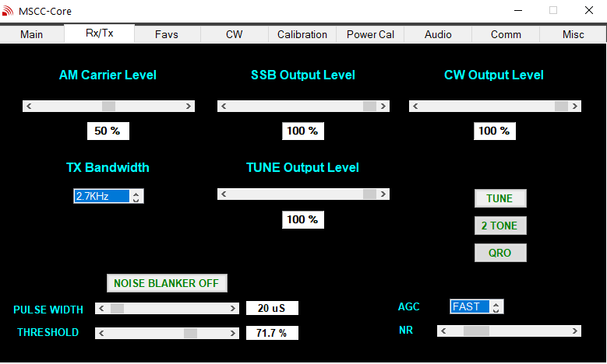

☐ 6. Favs Tab
The Favs (favorites) tab is for storing favorite frequencies and modes.. The favorites are are stored in a band stacking mode of operation. Each band has twenty available “slots” to store frequency and mode. Each time UPDATE BAND STACK is pressed the current frequency and mode is stored in the next slot in rotation. When all twenty slots are occupied and UPDATE BAND STACK is again pressed, the frequency and mode data will over wright the data in slot 1. Example: Update → slot 1, Update → slot2, … Update → slot 20,
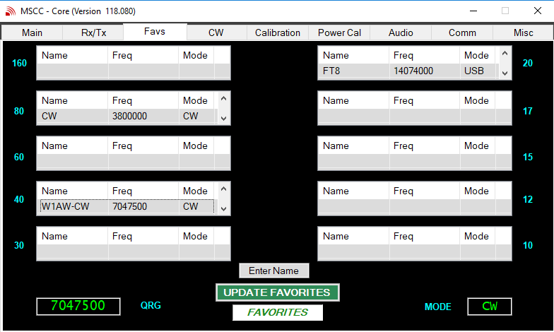
Update → slot 1, Update → slot 2, Update → slot 3 and so on. The UPDATE BAND STACK automatically selects the correct band stack based on the current frequency and mode.

A favorite may be named. Before pressing the UPDATE FAVORITES button, enter a name in the Enter Name field. If a name is not desired, simply press the UPDATE FAVORITES button. The name of favorite will be the current frequency.

☐ 7. CW Tab
This displays commonly used CW operating features.
TX Hold Time. This value determines the length of time transceiver will remain in TX mode after the key is released.
Semi Break-in. This sets the transceiver to automatically turn TX on when the key is pressed.
CW PITCH. The CW PITCH list box sets the receive pitch of the received CW Signal. It has fixed pitch values of 400Hz, 500Hz , 600, Hz, 700Hz and 800Hz. The default is 600Hz
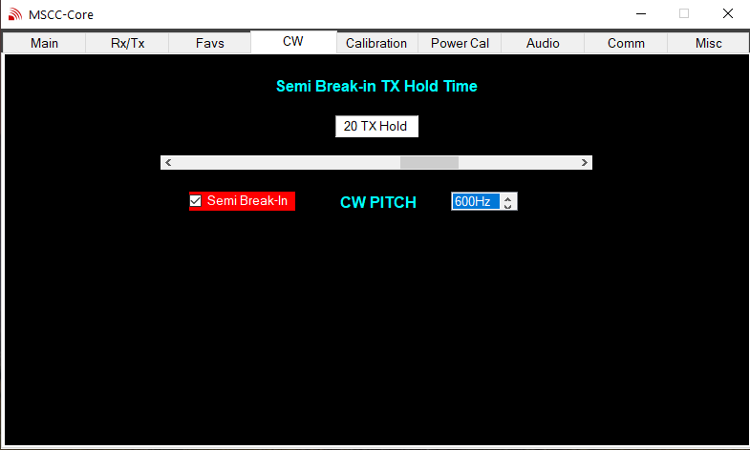

☐ 8. Calibration Tab
The calibration has two main functions. One is for calibrating the transceiver internal oscillator and the other function is for balancing the I/Q signal sent and received from the transceiver.

Frequency Calibration
The transceiver implements a very stable and accurate main oscillator (Si5351). However the crystal that drives the oscillator may vary from the default of 25MHz from crystal to crystal. To compensate for this, the transceiver MAY NEED calibrated. Press the CHECK button to check the current calibration. If further calibration is desired continue on with the remainder of this section.

The calibration routine has two modes of operation, coarse mode and fine mode. The coarse mode is performed first and then if desired, a fine mode calibration.
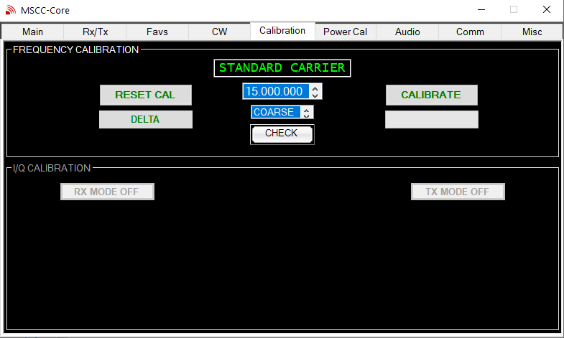
NOTE: If a Coarse or Fine calibration is initiated, do not leave this tab before the calibration is complete. Otherwise the transceiver may be left in an indeterminate state and power reset may be required.

Coarse Mode Calibration
The following describes the procedure for “coarse mode” calibration.
- Press the S-Meter and PANADAPTER buttons on the main tab.
- Select the Calibration tab and select a standard carrier in the list box. This will select a standard carrier transmission from a list of standard carriers. Select a standard carrier of the highest frequency with a S9 receive level or better for best calibration.
- Press the RESET CAL button. This will reset the transceiver calibration.
- Select COARSE in the list box.
- Now press the CALIBRATE button. The CALIBRATE button will change to “CALIBRATING”
- The calibration process will take between 3 and 5 minutes to complete.
- When the calibration process is complete the CALIBRATE BUTTON will change to “CALIBRATED”.
- The coarse mode of frequency calibration of the transceiver is now complete.

Fine Mode Calibration
The fine mode may be executed after an initial coarse mode calibration is performed. Fine mode calibration will bring the transceiver with 1Hz to 2Hz of the standard carrier frequency.
- Select a Standard Carrier frequency as item #1 above.
- Select FINE from the list box
- Click the CALIBRATE button. The fine calibration routine will start.
- When the calibration process is complete the CALIBRATE BUTTON will change to “CALIBRATED”.
- The fine mode of frequency calibration of the transceiver is now complete.

NOTES:
- Do not press the RESET button when running a fine calibration. RESET completely resets the transceiver calibration. A warning pop up will be displayed when the RESET button is pressed.
- A coarse calibration will take approximately 5 minutes to complete. A fine calibration will take approximately 3 minutes to complete.
- The coarse mode of calibration will calibrate the transceiver to within +/- 10Hz of the standard carrier frequency.
- The coarse calibration data is stored in an initialization file for future reference.
This file is consulted when additional fine calibrations are executed and is a starting point for the fine calibration.
- The transceiver may blink C while in calibration mode.

I/Q Transmit Calibration
Multus SDR, LLC transceivers use Tayloe balanced mixers to produce the signal to be amplified by the final amplifier. Audio I and Q signals feed the mixer along with a local oscillator signal. The I and Q audio signal need to be very close in amplitude, otherwise image signals may be produced in the output signal. The transceiver without I/Q balance calibration exceeds the FCC requirement of spurious radiation of 43db below carrier. However with I/Q calibration, the I/Q image(s) can be reduced to well below 60 db below carrier. The I/Q calibration routine permits adjusting the I/Q balance on a per band basis.
I/Q calibration is easiest to perform if a Multus SDR IQBD has been purchased. The IQBD detects out of balance I/Q conditions.
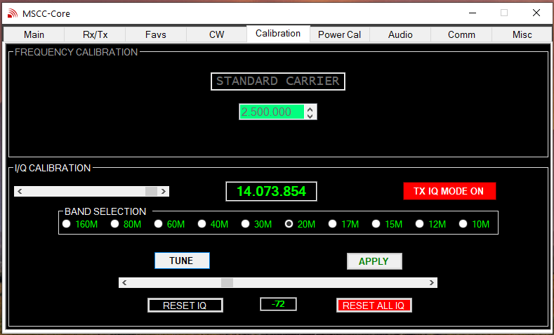

Procedure for adjusting the I/Q balance using the IQBD.
- Attach the IQBD to the antenna connection of the transceiver.
- If not already in the Calibrate Tab, select the Calibration tab and then click the TX MODE OFF button. This will present the controls for adjusting the transmit I/Q balance.
- Select a band for calibration.
- Press the TUNE button
- Move the slider left or right from center obtaining the minimum flicker as possible of the IQBD LED.
- Select FINE from the list box
- Move the slider left or right to obtain minimal LED flicker. On some bands (particularly 80M and 40M) the LED may be completely extinguished.
- Press the APPLY button to record this I/Q balance.
- The I/Q balance is now complete for the chosen band.
- Repeat steps #2 through #9 for other bands.

Once the I/Q balance is adjusted for all bands, it will not need to be performed again unless the transceiver is installed on a different computer.

Procedure for adjusting the I/Q balance using a second receiver method.
- Click on the Calibration tab, click on TX MODE OFF button.
- Click the band to be calibrated. The window now displays the calibration frequency.
- Set a second receiver to CW and tune either up or down 24KHz from the frequency shown.
- Click the TUNE button. Now slowly tune the second receiver until a tone (it will be very close to the frequency shown in the display window +/- 24KHz) is heard.
- Slide the scroll bar until the tone is at minimum volume. Clicking the scroll bar changes the IQ balance value in increments of 10. Using the mouse wheel changes the IQ balance in increments of 1.
- When the IQ is balanced, click the APPLY button.
- IQ calibration is now finished for the chosen band.
NOTE: It is easy to overload the front end of the second receiver even at 5W. Be sure the second receiver antenna is sufficiently distant from the Proficio dummy load (or even disconnect the second receiver antenna).
--

I/Q Receive Calibration
Receiving with the transceiver may experience a similar issue as with transmit I/Q balance. The procedure for setting the I/Q balance per band is similar to the procedure for calibrating the transmit I/Q balance.
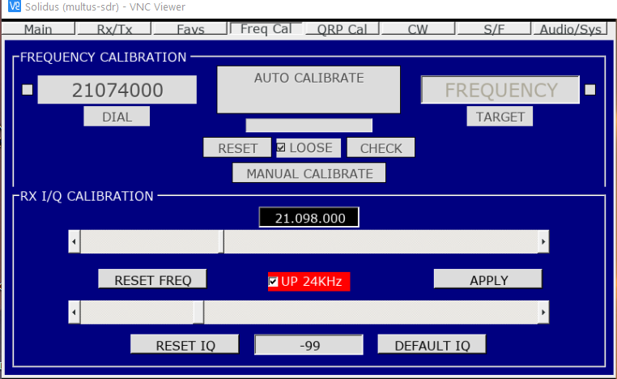
- Select the CW mode of operation.
- Select a band and frequency that has strong signal (S9 or better), preferably a CW signal (the ARRL W1AW code sessions provide a good signal to use).
- Tune the signal so that the S-Meter provides the highest reading.
- Click on the Freq Cal tab and click the RX IQ button.
- Click the UP 24KHz button.
- If the I/Q is out of balance there may be a weak signal at or near this frequency. Using the frequency slider, slowly tune UP and DOWN and tune for the image signal.
- Now, using the IQ slider, adjust the IQ balance until the signal is inaudible (or very close to inaudible).
- When satisfied with the IQ balance, press the APPLY button.
- I/Q receive balance is now complete for the chosen band.
- To calibrate additional bands, click on the MAIN tab and select different band and frequency and repeat the above steps.

NOTES:
- The IQ slider has two increment settings. Clicking in the slider changes the IQ setting in increments of 10. Using the mouse scroll wheel changes the value in increments of 1.
- The I/Q balance settings are known only to the PC where MSCC is running They are not stored in the transceiver. If the transceiver is used with other host applications, the I/Q balance calibration will need to be performed within that application.
- Detecting the image signal maybe difficult. The transceiver as delivered has an image rejection of -43db or better. Listen carefully for the image. Most times it is easier to hear the signal than to see it on the panadapter.

☐ 9. Power Cal Tab
This tab is used for output power calibration. The transceiver as delivered will supply 4W to 5W on all bands. However, due to variations in component tolerances the output power on one or multiple bands may not be optimal. This tab allows for the calibration of the output power on a per band basis. See Appendix A for instructions for using the calibration routine.
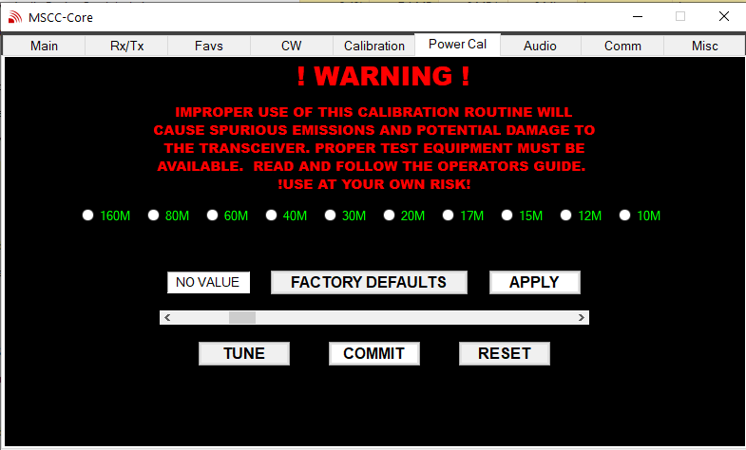

☐ 10. Audio Tab
- The audio tab provides for the selection of the speaker and microphone devices attached to the host computer. Simply click on a device to select it.
- Transmit Audio Compression. Compression amplifies lower-level speech and limits peaks, providing higher average "talk power" without increasing distortion. Compression may be adjusted in a range of 0db (no compression) to 20db (maximum compression) and may simply be turned on and off. Setting the compression value will be unique to each operators voice and operating conditions. There is some interaction between Mic gain and compression. The Mic gain may need reduced when compression is on. Make sure the OVER DRIVEN indicator does not flash when using compression.
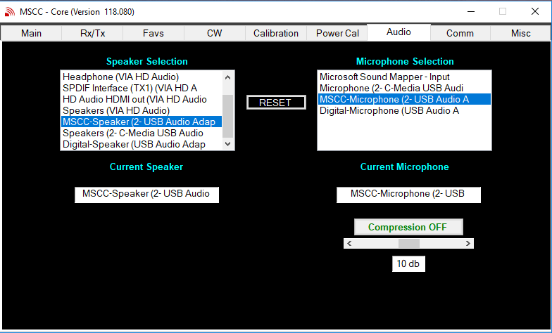

Notes:
- When MSCC is installed and run for the first time, it will populate the speaker and microphone list boxes with all devices audio known to the computer.
- The computer will have speaker and microphone defaults set. MSCC will select the default devices the first time it is run. When a speaker and microphone are selected, MSCC will remember the selection over subsequent restarts.
- The RESET button is used to reset the list of available audio devices. Pressing the RESET button informs the MSCC companion processes to perform an initialization on the next restart of MSCC. Use the RESET button if the audio configuration of the PC has changed since MSCC was last used.
- There are a number of places audio levels may be configured when using transceivers of the type Multus SDR, LLC provide. Audio levels will (on a Windows based PC) be at these locations and all have an impact on the functioning of the transceiver:
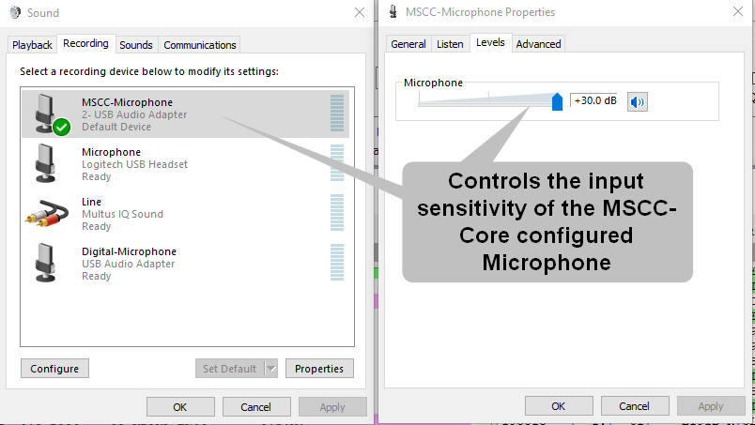
  - Below is the starting point for configuring the first of three places microphone volume may be adjusted. This is the Windows sound configuration window. The microphone sensitivity is adjust here. Experience has shown it is best to set this to maximum.
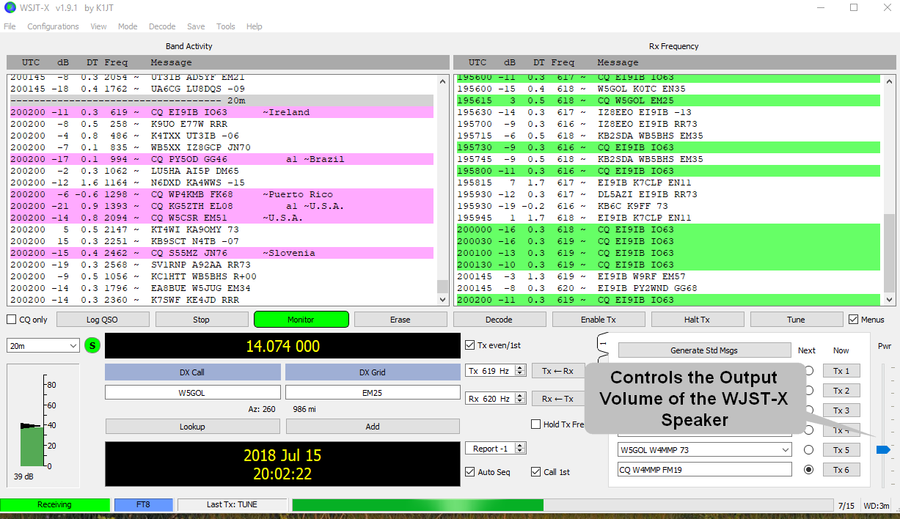
  - The second area where microphone volume may be adjusted. This control sets the output volume of the WSJT-X speaker. Whether the speaker is a virtual or physical audio adapter, the setting determines the drive level that is sent to the attached microphone connection (again, virtual or physical). Experience has shown it is best to set this to the level as presented in the illustration.
  - The third and final area where microphone volume (gain) may be adjusted. It controls the internal gain of the MSCC internal DSP engine. As a function of gain, it also controls the output power of the transceiver when the transceiver mode is set to LSB or USB. For QRP mode set this control to a point just below where the MIC GAIN flashes OVER DRIVEN. This will provide maximum power output. When the transceiver is attached to a linear power amplifier, adjusting this control also controls the output power of the amplifier.

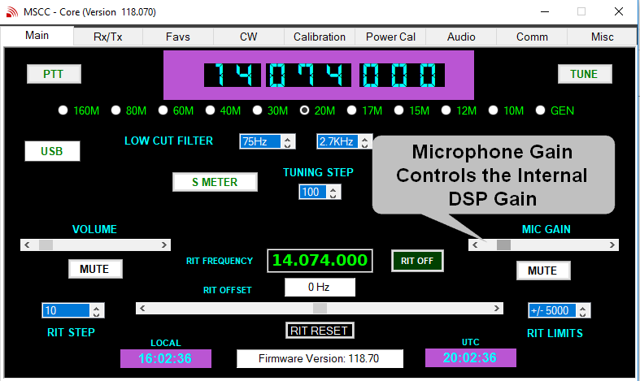

☐ 11. Comm Tab
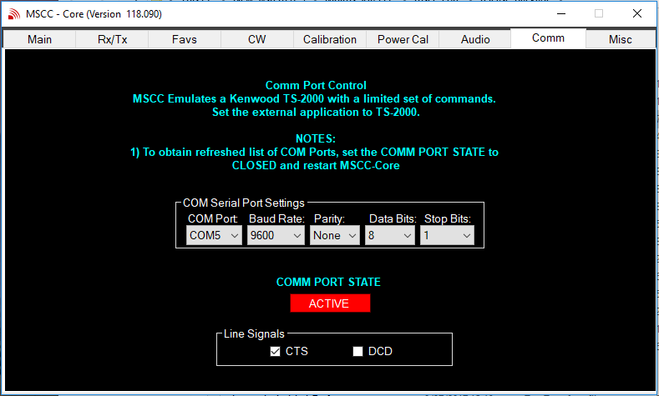
The comm tab provides for the selection of an asynchronous communications port. This port is normally used to interface with another digital application such as WSJT-X. WSJT-X will also have a communications port selected. The selected ports are not permitted to be the same port. The ports may be physical hardware ports or virtual communication ports provided by an application such as com0com.
- MSCC will populate the COM Port list the first time it is started. It will remember the available communication ports across subsequent restarts. elect a COM port and the other associated parameters.
- If COM Port signal control of PTT is desired, select a pin (CTS or DCD) as the controlling pin.
- Click the button. MSCC will open the port and change the button to ACTIVE. MSCC will maintain the state of the port across subsequent restarts.
NOTES:
- A COM port may only be selected when the COMM PORT STATE is in the CLOSED condition.
- If the configuration of the PC communication ports has changed while MSCC is running, set the COMM PORT STATE to CLOSED and restart MSCC. Upon restart the COM Port list will be refreshed with the current configuration

☐ 12. Misc Tab
The Misc Tab has a number of functions.

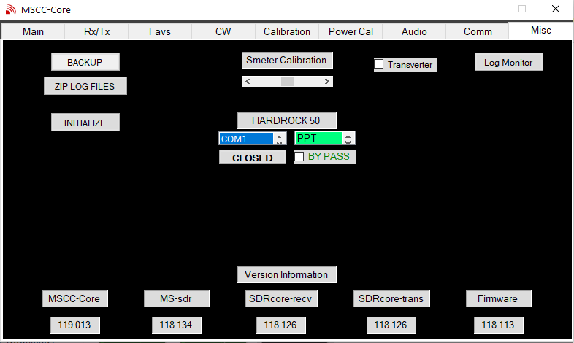
- Transverter. When the transverter function is active, the transmit limit of 10M is extended to 30MHz. This is intended to be used with transverters ONLY. It is the operators responsibility to ensure the transceiver is not transmitting outside the legally permitted frequencies.
- Log Monitor. Click this button will display a log monitor. It used primarily for debugging purposes. If problems arise while using MSCC, Multus SDR, LLC may request the monitor be activated and a copy of the entries be forwarded.
- Version Information. These boxes display the current version of all cooperating MSCC programs. NOTE: the versions will change with new release-packages and most likely will not match the below illustration.
- Backup. The backup button provides for backing up all the configuration files.
- Zip Log Files will create a zip file of all the configuration and log files and place the zip file in the release-package directory. The zip file is used for diagnostic purposes by Multus SDR, LLC if problems arise.
- The INITIALIZED button deletes the main run time initialization file. Upon restart of MSCC, the window requesting the PCB version of the transceiver will be presented and MSCC will be re-initialized.
NOTES:
The S Meter Calibration function is in BETA development mode.

☐ 13. Operating CW
- Attach a straight key or electronic keyer to the key port of the transceiver. Attach the key with a 3.5mm stereo plug. Wire the key to either tip or ring and ground (sleeve). Side tone generation is not provided by the transceiver or MSCC. Most electronic keyers have provisions for generating side tone. If a straight key is used a provision must be made to provide side tone.
- In main tab of MSCC select the band and frequency to operate.
- In main tab of MSCC select CW mode. This will place the transceiver into CW mode.
- There are two methods for setting the transceiver into TX mode.
One method is manual PTT. Press the PTT button on the main tab. The transceiver will enter TX mode. However, no power will be generated until the key is used. Use the key to generate CW.
The second method is to use Semi Break-in PTT. Click the semi break-in check box of MSCC on the CW tab. In this mode transceiver will automatically go into TX mode when the key is pressed. Adjust the TX Hold time to your individual preference.
- When the transceiver is in CW mode, the LED will blink the letter “C” indicating it is in CW mode.

☐ Appendix A: Output Power Calibration
!WARNING!
IMPROPER USE OF THIS CALIBRATION ROUTINE WILL CAUSE SPURIOUS EMISSIONS AND POTENTIAL DAMAGE TO THE TRANSCEIVER. PROPER TEST EQUIPMENT MUST BE AVAILABLE.
USE AT YOUR OWN RISK!
The following calibration procedure must be read and understood before performing power output calibrations. Failure follow the procedure exactly as presented or without the use of proper test equipment may lead to improper operation of the transceiver.
The user assumes all responsibility for using this calibration procedure and the results thereof.
Required Test Equipment:
- 50Ω Dummy load (10W or better) (non inductive, non reactive).
- Calibrated oscilloscope, RF Probe or calibrated watt meter (capable of low power measurements).
- 13.8V regulated power supply.
Do not attempt the calibration routine unless the equipment listed above is available.
Calibration Procedure. Calibrating the transceiver is an iterative process. An output power measurement is taken. The output power is adjusted and another output power measurement is taken. This is performed multiple times until the output power is at maximum output BUT NOT EXCEEDING 5W. SETTING THE OUTPUT POWER BEYOND 5W WILL CAUSE SPURIOUS EMISSIONS AND MAY DAMAGE THE TRANSCEIVER. ALSO, DO NOT APPLY THE POWER VALUES WHILE THE TRANSCEIVER IS IN “TX” MODE. THIS WILL CAUSE THE TRANSCEIVER TO LOCK UP AND A POWER CYCLE WILL BE REQUIRED.
NOTE: The term “Power” used below is a relative number. It is not the absolute power output of the transceiver. The “Power” value below is a value between 30 and 90. This number relates to a real power output of less than 1 watt to 5 watts.
Each band is calibrated individually. Select a band, perform the calibration routine as presented below and then select another band and perform the calibration routine again. This may be performed for all bands if necessary.

NOTE: Before performing the steps below, click on the RxTx tab and set TUNE to maximum. Review the following before proceeding.
- Attach the dummy load to the transceiver. A “T” connector or some other means for attaching the measuring device is required (unless using a watt meter). If a patch cable is necessary use a high quality and short 50 Ω cable.
- Power on the transceiver.
- Start MSCC and click on the Power Cal tab.
- Click on a band radio button. This will select the band for calibration.
- Click on the TUNE button. Make note of the power output. Now click on the TUNE button to return to RX mode. NOTE: Be sure the TUNE Output Level slider on the Rx/Tx tab is set to maximum.
- On the Power Cal tab move the slider to the right. Clicking in the white space to the right of the slider cursor will increase the power by 5 with each click.
- Now click “APPLY”. This will apply the new output power value. The new value will be displayed in the box to the left of the FACTORY DEFAULTS box.
- Click on TUNE and make note of the Power output. Click TUNE again to return to RX mode.
- Perform steps #7 through #9, slightly increasing the power value with each iteration until the power is at maximum output or 5W but never over 5W.
- If increasing the value of the power slider causes a decrease of output power, STOP. The PA is being over driven. Perform step #11 to correct the over driven condition.
- Click on the RESET button. This restores the slider to a default value of 40. Perform steps #7 through #9 again and be sure to not to exceed the value that caused the over drive condition. Or press the FACTORY DEFAULTS button to restore the values to the default values. Now perform steps #7 through #9 again.
- The calibration is now complete for the selected band. Another band may now be selected for calibration.
- When calibration of the chosen bands is complete, press the COMMIT button. This commits all the power calibration values to the transceiver and updates the EEPROM in the transceiver. NOTE: The COMMIT button must be press before leaving the calibration tab or the calibration values will be lost.

☐ Appendix B: New transceiver installation.
When installing the transceiver on a PC that has never had a Multus SDR, LLC, transceiver attached, a device driver installation is required. Follow the steps below to install the required device driver.
- Attach the transceiver to an available USB port on the PC.
- Power cycle the transceiver.
- Navigate to the release package previously installed on the PC.
- Navigate to the Firmware directory in the release package.
- Click (or double click) on Zadig to start Zadig.
- Multus SDR Control should be displayed in the device box. If is not listed, click on Options - > List All Devices. The in the drop down select Multus SDR Control.
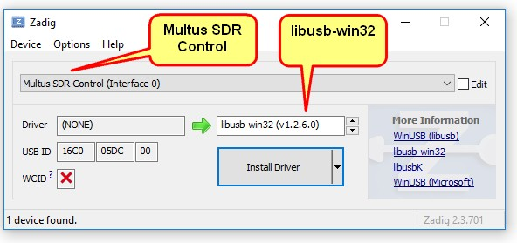
- Click “Install Driver”
- If the driver installation is successful, Zadig will automatically close.
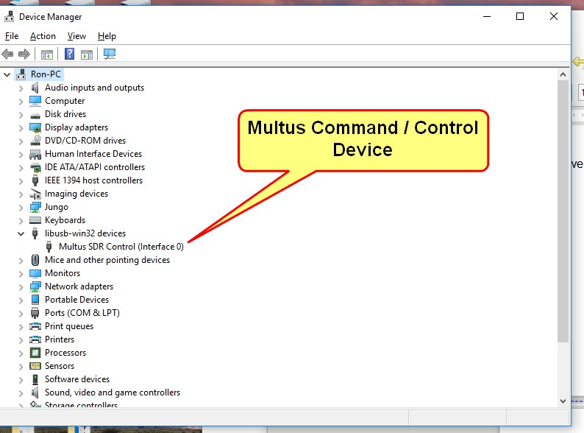
- Bring up the Windows Device Manager Window. If all goes well the transceiver will be a device listed under the libusb-win32 devices category.
- The device driver installation is now complete. Return to section #2 of this manual to complete the application software installation.

☐ Appendix C: Firmware Updates.
NOTE: If the current firmware version is prior to 117.111 consult Appendix D before proceeding with this section.

There are two methods available for updating the firmware, USB Bootloader and using a miniProg3 programmer.

USB Bootloader
When the BOOT jumper is in the BOOT position (jumper across pins 1 and 2) the LED will blink BOOT in Morse code.
NOTE: Newer versions of the firmware will blink "LOADER".
In this mode the radio is ready to accept firmware.
Note: The most current version of the firmware will be in the firmware directory previously installed.

Make sure the BOOT jumper is on the header (pins 1 and 2) and the radio is powered and connected. The LED will blink “BOOT” or “LOADER”. Now start the bootloader host application by clicking on the USBBootloaderHost icon on the desktop. The bootloader host application will indicate it is connected to the transceiver.
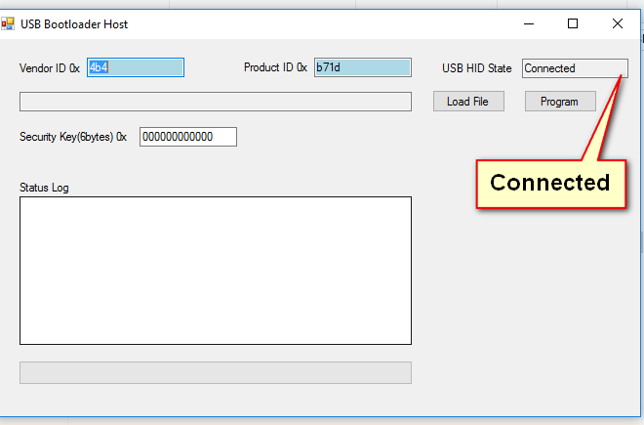
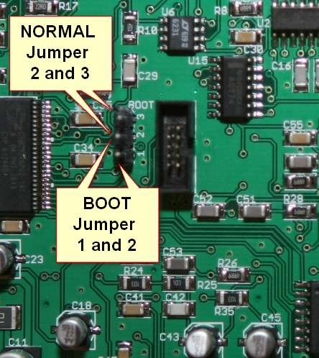

Choose “Load File then “Open...’’ from the menu. Select the {name}.CYACD file for the firmware located in the firmware directory previously installed.
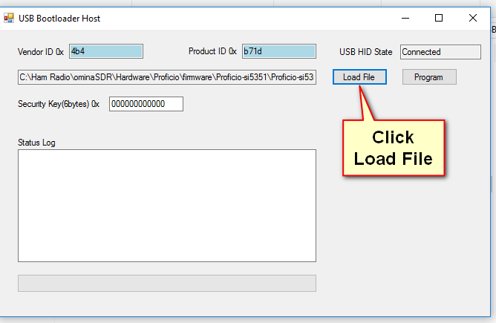

Now click “Program”. In a few seconds the new firmware will be loaded and a success message will be reported. Move the jumper back to run mode (pins 2 and 3) and power cycle the radio by interrupting power.
NOTE: Do not interrupt the firmware update.
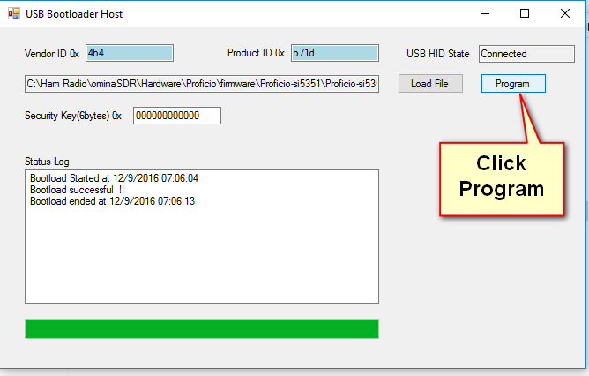

The firmware update is now complete.
☐ SWD Programming
A 10-pin SWD connector is included with every radio for connecting a Cypress MiniProg3 or other programmer. This method is for advanced users who should be familiar with the process.
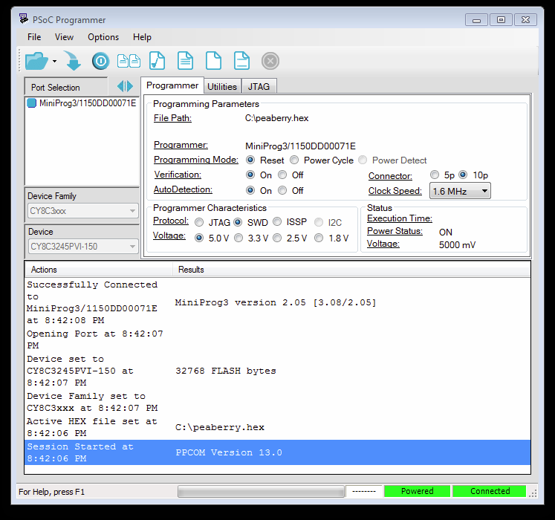

File Path: Choose the .HEX file
Programming Mode: Reset
Connector: 10p
Protocol: SWD
Voltage: 5.0V

☐ Appendix D: Upgrading firmware from versions prior to 117.111
The name of the transceiver device as presented to Windows has been changed from “Peaberry” to “Multus”. To affect this change additional steps need to be accomplished when upgrading the firmware.
- Update the firmware as presented in Appendix C. Be sure to move the boot jumper to normal run mode and power cycle the transceiver.
- Using the Windows device manager, delete (uninstall) the “Peaberry SDR” and “Peaberry Radio” devices. This will be listed under “libusb-win32-devices” and “Sound, video and game controllers”. If the device manager pop up presents the option to remove the driver, select that option.
- Unplug the USB connection of the transceiver from the PC, power cycle the transceiver and reboot the PC.
- Now plug in the transceiver USB connection and follow the instructions below.
The Multus SDR transceiver appears as a sound card with the name “Multus IQ Sound” with the current version of the firmware and should have been automatically installed by Windows because it is a standard USB audio device.
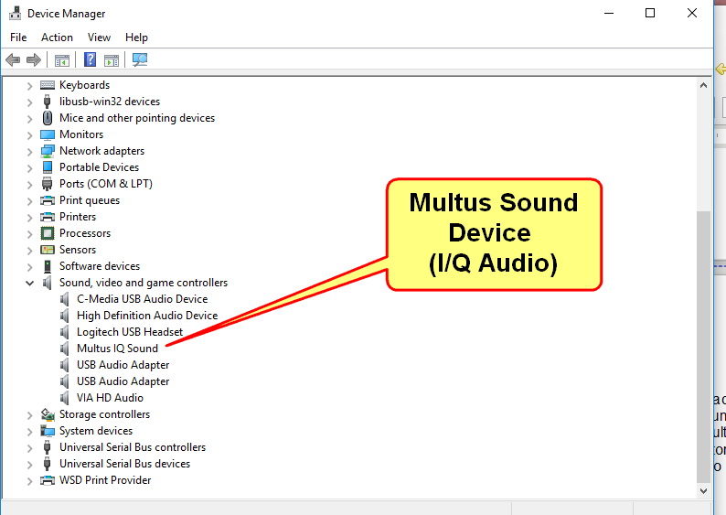

NOTE: DO NOT RUN the Zadig utility on the Multus I/Q Sound device.

There should also be a “Multus Control” device which needs a device driver.

Windows requires a device driver. Zadig is a utility for installing the proper driver.
Move to the FIRMWARE directory which is in the release-package directory previously installed. The Zadig utility will install the correct driver for the transceiver. Start Zadig.
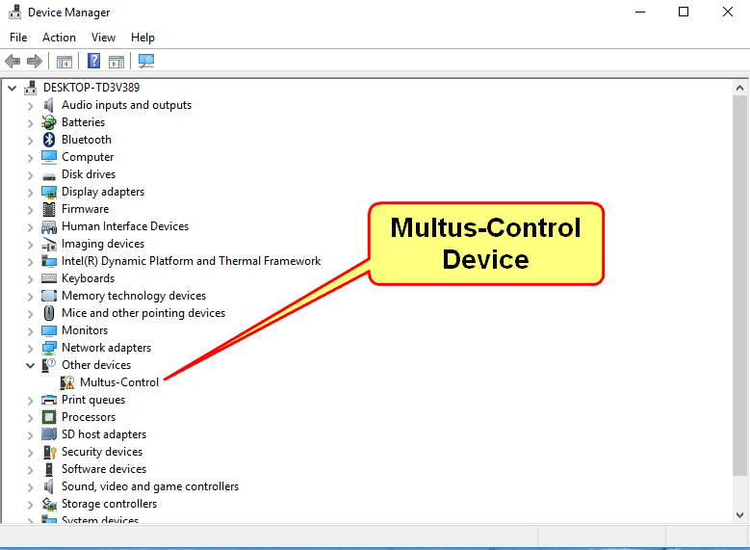

1) Multus SDR Control should be displayed in the device box. If is not listed, click on
Options - > List All Devices. The in the drop down select Multus SDR Control.
2) Click “Install Driver”

If the driver installation is successful, Zadig will close.

If everything goes well then the other/unknown in Windows device manager window will will change to display the following:

Driver installation is now complete.

☐ Appendix E: Operating Notes
- When operating on a laptop type computer, it is recommended a mouse be used with MSCC. Operating convenience is much better with a mouse. If the computer is Bluetooth capable, a Bluetooth mouse is highly recommended.
- Operational log files are maintained for trouble shooting and debugging purposes. The contents of the log files are reset when MSCC is started. Should a problem arise the log files may be requested to be sent to Multus SDR, LLC., for inspection. If a problem does occur, do not restart MSCC or the contents of the log files will be lost.

☐ Appendix F: Fortis Cube Notes

